Daniel Cender, Crystal Sciarrino, Alex Zoller

CST-361

March 7, 2021

Professor Charbel Elkhoury

Milestone Design Report

For the IoT project we plan on making a weather application to report, keep track and store remote weather data. We will be using a virtual embedded device to send weather information to the mySQL data base. This data includes temperature, humidity, the date and time, and the location in latitude and longitude. We will also create a web application following key API designs. The web application will connect to the database with the stored material and information. Correctly read the desired information then properly present the information in a graph setting or other not determined graphical or text presentation. The web application will also show off authentication and security. Also stored within the database we will have user information, such as username and password. The website will fetch that information securely and enable the existing user to log in. We will also provide a way for a new user to register for an account to be able to access this information. We will be following basic API structures, such as the REST and Bus API format. This will provide a secure way of retrieving and adding information to our database.

Each week as the milestone assignments is due. We plan on meeting periodically throughout the week to discuss and work on this project. We will set expectations for each other and help as needed. We will divide the work into three equally work loads so each of us can do our best, learn and show our talents. The application will be a presentation of our learning experience and will help us present our talents and what we have learned from this course and previous courses to provide an academic project. We are planning to adhere to the modern APIs and best practices to formulate a presentable and professional project.

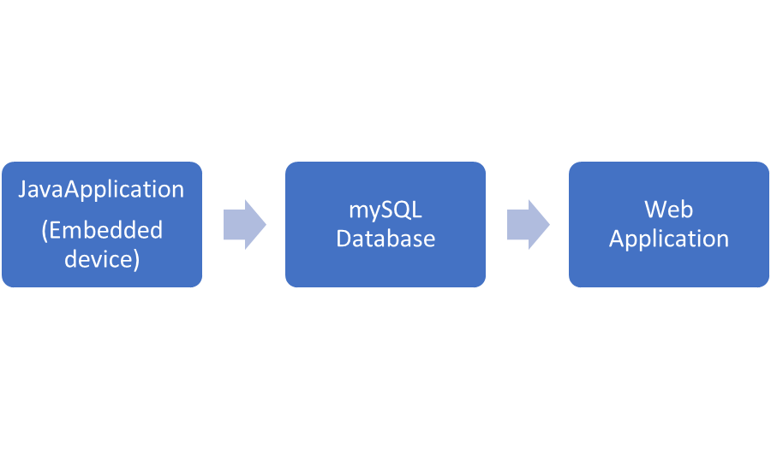

Java Application

This will be the embedded device that collects data, prepares the data then sends it to the mySQL. This will be a simulated device that captures data for humidity and temperature.

mySQL:

This will be the main location of all the data.

Web Application:

This will be the front-end web application that gets from our data base the data and presents it accordingly.